RUPESH MEHROTRA 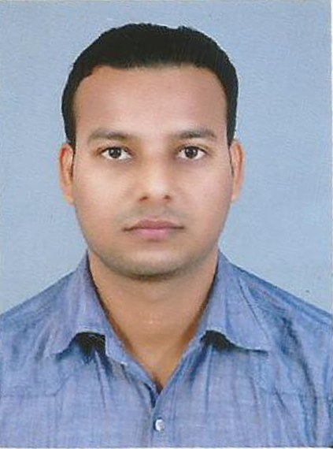
Mobile: 07800579764, 9454646088 Email: rupeshmehrotra01@rediffmail.com

CAREER OVERVIEW
A sales management professional with more than Four years’ experience , I have worked on product selling and market penetration, Promotional activities and Insurance products. I have a proven track record of developing new business and motivating a team to consistently exceed targets. Now seeking a new professional challenge.
KEY STRENGTHS
  - High level computer skills including Excel, Word and PowerPoint
  - Four and half years experience in customer service both face to face and phone based
  - Strong business development capabilities with Indian experience
  - Experience developing sales and marketing collateral
  - Active toastmasters public speaker
  - Recruitment skills and management o f team
CAREER HISTORY
June 2015- Present Assistant Manager (PB SALES) HDFC BANK LTD at (Gauriganj) DISTRICT- Amethi ( (UP)
KEY RESPONSBILTIES
- Acquisition of new Prefered Customers
- Enhancement of the relationship by cross selling products and services as per profile and need of the customers
- Deepening the size of the relationship
- Penetration of products across family groups and sales across all segments- TPP, Assets, Cards etc

April 2014 – MAY 2015 Assistant Relationship Manager (Bancassurance)
PNB METLIFE INDIA INSURANCE CO. LTD at Bahraich
Key responsibilities
- Achieving sales target
- Increase in no. Of SPs (specified person) /active branches
- Training SPs, encouraging PNB staff to become SP
- Arranging training programs for SPs on products and selling skills
- Maintain and strengthen a large portfolio of clients
- Manage sales budget and set targets
Key achievements- * Closed major deals and followed up business relationships with SPs.

November 2011- March 2014 Business Executive
NOVARTIS PHARMA at Banda (H.Q.)
Key responsibilities
- Develop relationships with doctors
- Manage all sales related aspects for allocated accounts
- Review product demand and service levels
- Identify new prospects and marketing opportunities
- To achieve territory target and exceed the fundamental of company.

PERSONAL INFORMATION
RUPESH MEHROTRA  Father : RAJESH MEHROTRA  Mother : MANJEET MEHROTRA  Address:491,BRAHMINIPURA BAHRAICH(U.P) PIN CODE-271801  Phone: 7800579764,  9454646088  E-mail: rupeshmehrotra01@rediffmail.com  Personal Data:  DoB: 20th March.1989  Sex: Male  Nationality: Indian  Marital Status: Married  Hobbies:  - Travelling , Music, Reading books  Strengths:  - Leadership  - Adaptive  - Goal oriented | Education :  Professional Qualification)  Two years Medical diploma in O.T.Technician from UP State Medical faculty Lucknow in the year 2009.  Graduation: Bsc. from J.S.S. Educational institute GONDA, Affiliated to Dr. R.M.L. Avadh University Faizabad.  Intermediate:  From U.P. Board In 2005  High School:  From U.P. board In 2003  ACHIEVEMENTS & EXPERIENCE  I got Outstanding performance award in Novartis pharma in April 2013  I got club membership award of “Rising Star Club” July 2014 in PNB METLIFE  I got “RH Club membership” award in August 2014 in PNB METLIFE  I got super achievers club award with dubai trip in november 2014 in PNB METLIFE  I have qualified the “GO GREEN” contest of life insurance business january 2016 in HDFC BANK  I have qualified “JUNE KA JUNOON” contest of Life insurance JUNE 2016 in HDFC BANK  CERTIFICATION  - AMFI  - IRDA  - Certificate course in InfoBase(Web)  INDUSTRIAL INTERACTION  - Prepared a Research report on an analysis of investors behaviour towards life Insurance Plan.

Declaration: I hereby declare that the above information is correct to the best of knowledge.

0.
DATE: RUPESH MEHROTRA
PLACE:

